Review:
1. Kinetic Energy: KE=__________ 2. Gravitational Potential Energy: PE = ___________

3. Mechanical Energy = KE + PE =_________________________

Other Forms of Energy:__________________________________

Energy can neither be created nor destroyed, but can only be transferred from one form to another.

How could energy be transformed?_____________________________

Definition of Work: W= ____________________________

The principle of Conservation of Mechanical Energy:

The mathematical presentation of Conservation of Mechanical Energy:

Conservative force:

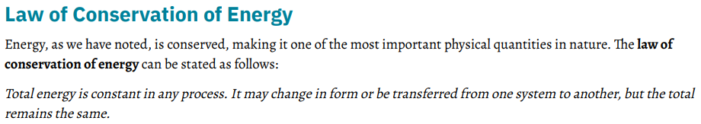
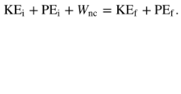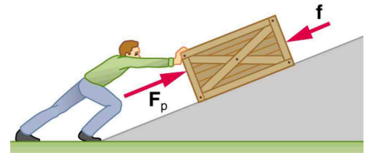
Conservation of Energy is consistent with Work-Energy Theorem:

${W_{net}=KE}_{f}-{KE}_{i}$ ${W_{nc}-({PE}_{f}-{PE}_{i})=KE}_{f}-{KE}_{i}$ ${{KE}_{f}{+{PE}_{f}-{(KE}_{i}}_{}+{PE}_{i})=}_{}W_{nc}$

Most moving objects experience nonconservative forces, such as friction, air resistance, and propulsive forces, and the work done by the net external nonconservative force is not zero. In these situations, the difference between the final and initial total mechanical energies is equal to according to the above equation. Consequently, the total mechanical energy is not conserved.
Conservation of Energy Examples:

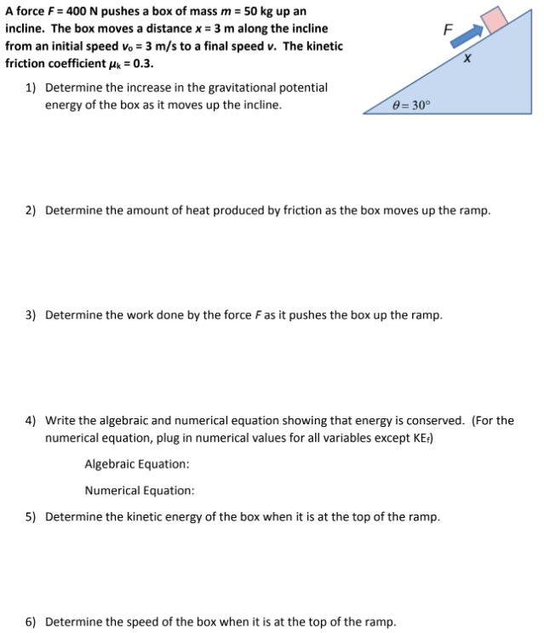

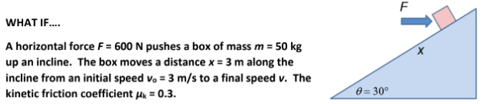

7) Use the Energy method to solve for the speed of the box when it gets to the top of the ramp.

8) A boy in a wheelchair (total mass 47.0 kg) has a speed of 1.40 m/s at the crest of a slope 2.60 m high and 12.4 m long. At the bottom of the slope, his speed is 6.20 m/s. Assume air resistance and rolling resistance can be modeled as a constant friction force of 41.0 N. Find the work he did in pushing forward on his wheels during the downhill ride.

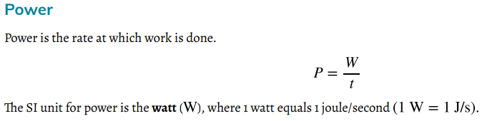
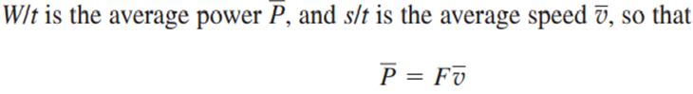
Example1
What is the power output for a 60kg woman who runs up a 3.00 m high flight of stairs in 3.5 s, starting from rest but having a final speed of 2.00 m/s?
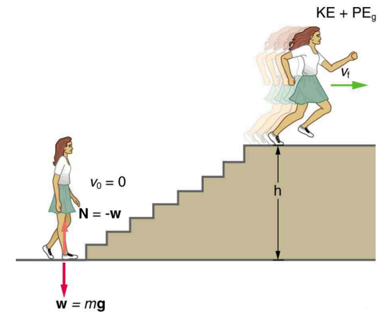

Practice Problems
29. An 820-N Marine in basic training climbs a 12.0-m vertical rope at a constant speed in 8.00 s. What is his power output?

